# **Architectural Diagram**

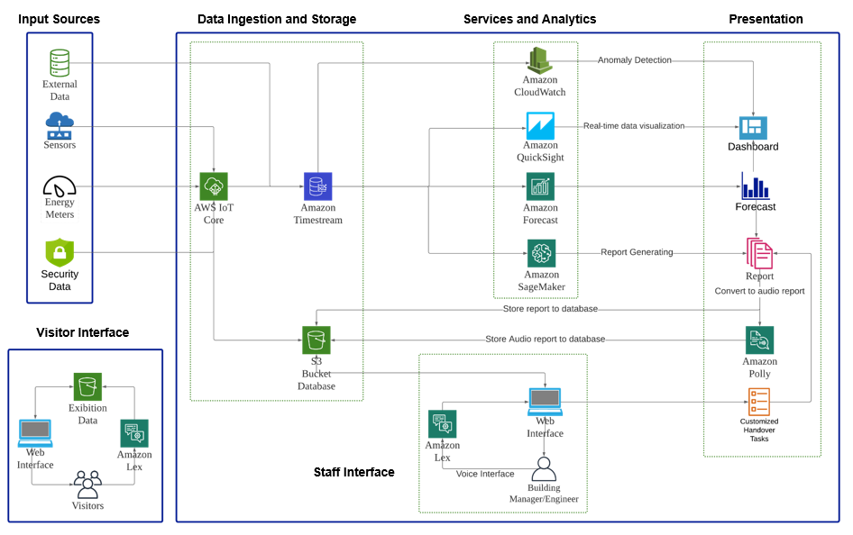

**Workflow Description:**

The solution is based on AWS cloud technologies[4]. Input data sources of the system include sensors of temperature, humidity, energy meters, and other data sources like cameras, security data, Weather forecast, etc. Surveillance cameras can be integrated with human detection algorithms to monitor visitor flows. This can help with keeping social distance and improving the visiting experience. AWS IoT Core is used to gather the input data from sensors and save the data to Amazon Timestream and S3 bucket according to data types. Amazon Timestream is a time-series database and an S3 bucket is for storing unstructured data.

Then data will be processed and analyzed in 4 branches, Amazon QuickSight, Amazon CloudWatch, Amazon Forecast, and Amazon SageMaker. QuickSight is used for generating a dashboard for building managers and engineers to monitor the whole building in real-time. CloudWatch[5] uses machine learning algorithms to continuously analyze input data for anomaly detection. We can set up thresholds for key metrics. If the threshold is reached, CloudWatch would trigger anomaly detection alarms. SageMaker is used for generating a report to summarise the building’s performance of the current shift and send it to the next shift staff for handover. Amazon Forecast[6] is used for providing forecasts utilizing machine learning based on historical time-series data. Short time forecasts are shown on the dashboard and forecasts for the next shift are provided on the handover report.

The handover report can be either sent to building managers’ and engineers’ emails using Amazon Simple Email Service or accessed from the web interface of the management system. Text parts of the handover report are transferred to audio format through Amazon Polly so that the staff can listen to the audio while traveling to work and get well prepared before the shift begins.

Besides interacting with the system from the visual interface, Amazon Lex is used for accessing the system with voice commands. Amazon Lex[7] leverages deep learning for automatic speech recognition and natural language understanding. It can be used to understand the purpose and convert speech to text. Building managers and engineers can ask Lex questions that they are interested in or send voice commands to Lex when they are not able to operate the system interface by hand. Then Lex transfers voices to code and query the database or execute the commands. Visitors to the museum can utilize a guest account with limited access to the system. The guest accounts only have access to the information of current exhibits and events through a web interface or asking Amazon Lex.